**Objectives**

1. Research information about software for a specific operating system (OS) environment. You will be assigned one of the operating systems form the list of: Windows, Mac OS, Linux. You will also be provided with a list of topics to investigate.
2. Organize your rough research information into a list of topics, sub-topics and facts. This process will involve identifying sub-topics, rearranging your rough research notes, and selecting (or highlighting) interesting facts.
3. Report a summary of your research in the form of a “concept map”. Use the PowerPoint template provided as a starting point. The concept map should only include the best and most interesting information from your organized research notes.

Your assigned operating system is:

* Windows
* Mac OS
* Linux
* iOS
* Android

A concept map can be created using the “Smart Ideas” application or PowerPoint or other applications.

**Level 1 – Rough Research**

Research information about the software for your assigned operating system (OS) environment.

* Guide your research according to the suggested topic list below
* Feel free to copy-and-paste as long as you keep track of your bibliographic references.
* Do not be too picky or concerned about formatting as you will organize this information later in step 2
* Select things that look interesting and don’t forget to include graphics images as well
* Upload your rough research notes to your repository when you are done.

**Topic A – Productivity, Entertainment & Other Software Applications**

## Alarms & Clock

There are three tools under the Windows 8/8.1 Alarms app: Alarm, Timer and Stopwatch. The renamed Alarms & Clock in Windows 10 Technical Preview adds a fourth, World Clock. For some reason, the app doesn’t feature the bold circular UI graphics of the old app.

**Calculator**

Here’s an app that will certainly work much better on a desktop and notebook computer because it’ll launch inside a resizable window on the Windows 10 desktop. The Windows 8/8.1 Calculator app comes with three modes: Standard, Scientific and Converter. The new one will add a fourth, Programmer. The user interface for the Converter has been redone. The measurements that can be converted will all be listed in a sidebar, not in a drop-down menu

## Calendar

The Calendar app gets a completely overhauled GUI and look that, thankfully, makes it far more usable on desktop and notebook systems. It will have feature integration with the also new Mail app.

## Camera

You’ll be able to change the resolution and frame rate for capturing video with the webcam of your Windows 10 device.

## Maps

The new Maps in Windows 10 Technical Preview works mostly the same as in Windows 8/8.1, with several new things added: the ability to rotate a map clockwise or counter-clockwise, and to view it at an angle tilted toward the horizon. There’s now a large selection of cities included that you can view as 3D maps. Another feature is you can download and install regional maps so you can use this app completely offline.

## Music

The Windows 10 Technical Preview doesn’t include this new Music app preinstalled; it has to be downloaded separately from the beta version of the new Windows Store app. Under the name Music Preview, this app has a planer GUI over its Windows 8/8.1 predecessor, and lacks any link to an online store to buy music as downloads or streams. A music store will likely be restored in the final release.

Apps that are only on windows:

* [3D Movie Maker](https://en.wikipedia.org/wiki/3D_Movie_Maker)
* [3D Topicscape](https://en.wikipedia.org/wiki/3D_Topicscape)
* [3D World Atlas](https://en.wikipedia.org/wiki/3D_World_Atlas)
* [Adobe Atmosphere](https://en.wikipedia.org/wiki/Adobe_Atmosphere)
* [Adobe eLearning Suite](https://en.wikipedia.org/wiki/Adobe_eLearning_Suite)
* [Adobe LiveCycle Designer](https://en.wikipedia.org/wiki/Adobe_LiveCycle_Designer)
* [Adobe Technical Communication Suite](https://en.wikipedia.org/wiki/Adobe_Technical_Communication_Suite)
* [Advanced Systems Analysis Program](https://en.wikipedia.org/wiki/Advanced_Systems_Analysis_Program)
* [Alcohol 120%](https://en.wikipedia.org/wiki/Alcohol_120%25)
* [Alpha Five (database)](https://en.wikipedia.org/wiki/Alpha_Five_(database))
* [List of alternative shells for Windows](https://en.wikipedia.org/wiki/List_of_alternative_shells_for_Windows)
* [Analyse-it](https://en.wikipedia.org/wiki/Analyse-it)
* [Ashampoo Burning Studio](https://en.wikipedia.org/wiki/Ashampoo_Burning_Studio)
* [AutoCAD Architecture](https://en.wikipedia.org/wiki/AutoCAD_Architecture)
* [Autodesk Revit](https://en.wikipedia.org/wiki/Autodesk_Revit)
* [AveDesk](https://en.wikipedia.org/wiki/AveDesk)
* [Awasu](https://en.wikipedia.org/wiki/Awasu)
* [BackupAssist](https://en.wikipedia.org/wiki/BackupAssist)
* [Bandicam](https://en.wikipedia.org/wiki/Bandicam)
* [The Bat!](https://en.wikipedia.org/wiki/The_Bat!)
* [BB FlashBack](https://en.wikipedia.org/wiki/BB_FlashBack)
* [BearShare](https://en.wikipedia.org/wiki/BearShare)
* [Biblioscape](https://en.wikipedia.org/wiki/Biblioscape)
* [BlindWrite](https://en.wikipedia.org/wiki/BlindWrite)
* [BMDP](https://en.wikipedia.org/wiki/BMDP)
* [BootVis](https://en.wikipedia.org/wiki/BootVis)
* [CADSTAR](https://en.wikipedia.org/wiki/CADSTAR)
* [CintaNotes](https://en.wikipedia.org/wiki/CintaNotes)
* [CloneCD](https://en.wikipedia.org/wiki/CloneCD)
* [CommSuite 95](https://en.wikipedia.org/wiki/CommSuite_95)
* [ConnectedText](https://en.wikipedia.org/wiki/ConnectedText)
* [Consultant Plus](https://en.wikipedia.org/wiki/Consultant_Plus)
* [Corel Photo-Paint](https://en.wikipedia.org/wiki/Corel_Photo-Paint)
* [CorelDRAW](https://en.wikipedia.org/wiki/CorelDRAW)
* [CounterSpy (software)](https://en.wikipedia.org/wiki/CounterSpy_(software))
* [CWShredder](https://en.wikipedia.org/wiki/CWShredder)
* [Cyberjack](https://en.wikipedia.org/wiki/Cyberjack)
* [Cygwin/X](https://en.wikipedia.org/wiki/Cygwin/X)
* [Daemon Tools](https://en.wikipedia.org/wiki/Daemon_Tools)
* [Daria's Sick, Sad Life Planner](https://en.wikipedia.org/wiki/Daria%27s_Sick,_Sad_Life_Planner)
* [DeepBurner](https://en.wikipedia.org/wiki/DeepBurner)
* [Desktop Architect](https://en.wikipedia.org/wiki/Desktop_Architect)
* [DesktopX](https://en.wikipedia.org/wiki/DesktopX)
* [Digital Scrapbook Artist](https://en.wikipedia.org/wiki/Digital_Scrapbook_Artist)
* [DirectSkin](https://en.wikipedia.org/wiki/DirectSkin)
* [Disc2Phone](https://en.wikipedia.org/wiki/Disc2Phone)
* [DiscJuggler](https://en.wikipedia.org/wiki/DiscJuggler)
* [Disk Cleanup](https://en.wikipedia.org/wiki/Disk_Cleanup)
* [DVD Decrypter](https://en.wikipedia.org/wiki/DVD_Decrypter)
* [DxDiag](https://en.wikipedia.org/wiki/DxDiag)
* [DynaRoad](https://en.wikipedia.org/wiki/DynaRoad)
* [E Text Editor](https://en.wikipedia.org/wiki/E_Text_Editor)
* [Easy Trace](https://en.wikipedia.org/wiki/Easy_Trace)
* [EMCO MoveOnBoot](https://en.wikipedia.org/wiki/EMCO_MoveOnBoot)
* [Encarta](https://en.wikipedia.org/wiki/Encarta)
* [EViews](https://en.wikipedia.org/wiki/EViews)
* [Ewido Networks](https://en.wikipedia.org/wiki/Ewido_Networks)
* [ExamDiff Pro](https://en.wikipedia.org/wiki/ExamDiff_Pro)
* [FastPictureViewer](https://en.wikipedia.org/wiki/FastPictureViewer)
* [FastStone Image Viewer](https://en.wikipedia.org/wiki/FastStone_Image_Viewer)
* [Femap](https://en.wikipedia.org/wiki/Femap)
* [FireDaemon](https://en.wikipedia.org/wiki/FireDaemon)
* [Garena](https://en.wikipedia.org/wiki/Garena)
* [Genstat](https://en.wikipedia.org/wiki/Genstat)
* [GoBack](https://en.wikipedia.org/wiki/GoBack)
* [GPU-Z](https://en.wikipedia.org/wiki/GPU-Z)
* [HiCAD](https://en.wikipedia.org/wiki/HiCAD)
* [IBM Lotus Word Pro](https://en.wikipedia.org/wiki/IBM_Lotus_Word_Pro)
* [Impulse (software)](https://en.wikipedia.org/wiki/Impulse_(software))
* [InCtrl5](https://en.wikipedia.org/wiki/InCtrl5)
* [Intellext Watson](https://en.wikipedia.org/wiki/Intellext_Watson)
* [IObit Malware Fighter](https://en.wikipedia.org/wiki/IObit_Malware_Fighter)
* [IObit Uninstaller](https://en.wikipedia.org/wiki/IObit_Uninstaller)
* [IRONCAD](https://en.wikipedia.org/wiki/IRONCAD)
* [IvsEdits](https://en.wikipedia.org/wiki/IvsEdits)
* [JAWS (screen reader)](https://en.wikipedia.org/wiki/JAWS_(screen_reader))
* [JRiver Media Center](https://en.wikipedia.org/wiki/JRiver_Media_Center)
* [Jubster](https://en.wikipedia.org/wiki/Jubster)
* [Lingoes](https://en.wikipedia.org/wiki/Lingoes)
* [Google Lively](https://en.wikipedia.org/wiki/Google_Lively)
* [MagicTracer](https://en.wikipedia.org/wiki/MagicTracer)
* [Mailtraq](https://en.wikipedia.org/wiki/Mailtraq)
* [Mathcad](https://en.wikipedia.org/wiki/Mathcad)
* [MedCalc](https://en.wikipedia.org/wiki/MedCalc)
* [Microfit](https://en.wikipedia.org/wiki/Microfit)
* [Microsoft Desktop Optimization Pack](https://en.wikipedia.org/wiki/Microsoft_Desktop_Optimization_Pack)
* [Microsoft MapPoint](https://en.wikipedia.org/wiki/Microsoft_MapPoint)
* [Microsoft Office 2000](https://en.wikipedia.org/wiki/Microsoft_Office_2000)
* [Microsoft Office 2003](https://en.wikipedia.org/wiki/Microsoft_Office_2003)
* [Microsoft Office 2010](https://en.wikipedia.org/wiki/Microsoft_Office_2010)
* [Microsoft Office Picture Manager](https://en.wikipedia.org/wiki/Microsoft_Office_Picture_Manager)
* [Microsoft Office XP](https://en.wikipedia.org/wiki/Microsoft_Office_XP)
* [Microsoft PhotoDraw](https://en.wikipedia.org/wiki/Microsoft_PhotoDraw)
* [Microsoft Visual Studio](https://en.wikipedia.org/wiki/Microsoft_Visual_Studio)
* [Minitab](https://en.wikipedia.org/wiki/Minitab)
* [Mod4Win](https://en.wikipedia.org/wiki/Mod4Win)
* [Motor-CAD](https://en.wikipedia.org/wiki/Motor-CAD)
* [MyColors](https://en.wikipedia.org/wiki/MyColors)
* [NCSS (statistical software)](https://en.wikipedia.org/wiki/NCSS_(statistical_software))
* [NetMiner](https://en.wikipedia.org/wiki/NetMiner)
* [NewWave](https://en.wikipedia.org/wiki/NewWave)
* [NMath](https://en.wikipedia.org/wiki/NMath)
* [NMath Stats](https://en.wikipedia.org/wiki/NMath_Stats)
* [Norton AntiBot](https://en.wikipedia.org/wiki/Norton_AntiBot)
* [Nvidia System Tools](https://en.wikipedia.org/wiki/Nvidia_System_Tools)
* [ObjectDock](https://en.wikipedia.org/wiki/ObjectDock)
* [PagePlus](https://en.wikipedia.org/wiki/PagePlus)
* [Perfect Dark (P2P)](https://en.wikipedia.org/wiki/Perfect_Dark_(P2P))
* [Physalis (software)](https://en.wikipedia.org/wiki/Physalis_(software))
* [Pokki](https://en.wikipedia.org/wiki/Pokki)
* [Project Unreality](https://en.wikipedia.org/wiki/Project_Unreality)
* [Pulsonix](https://en.wikipedia.org/wiki/Pulsonix)
* [Rails Across America](https://en.wikipedia.org/wiki/Rails_Across_America)
* [Rainmeter](https://en.wikipedia.org/wiki/Rainmeter)
* [Registry cleaner](https://en.wikipedia.org/wiki/Registry_cleaner)
* [RetroUI](https://en.wikipedia.org/wiki/RetroUI)
* [Revo Uninstaller](https://en.wikipedia.org/wiki/Revo_Uninstaller)
* [RootkitRevealer](https://en.wikipedia.org/wiki/RootkitRevealer)
* [Roxio Creator](https://en.wikipedia.org/wiki/Roxio_Creator)
* [Rybka](https://en.wikipedia.org/wiki/Rybka)
* [Scientific WorkPlace](https://en.wikipedia.org/wiki/Scientific_WorkPlace)
* [SciRef](https://en.wikipedia.org/wiki/SciRef)
* [SDI Tools](https://en.wikipedia.org/wiki/SDI_Tools)
* [Serif products](https://en.wikipedia.org/wiki/Serif_products)
* [SHAZAM (software)](https://en.wikipedia.org/wiki/SHAZAM_(software))
* [SigmaStat](https://en.wikipedia.org/wiki/SigmaStat)
* [SignPlot](https://en.wikipedia.org/wiki/SignPlot)
* [Simul](https://en.wikipedia.org/wiki/Simul)
* [SliderDock](https://en.wikipedia.org/wiki/SliderDock)
* [SolidWorks](https://en.wikipedia.org/wiki/SolidWorks)
* [SPC XL](https://en.wikipedia.org/wiki/SPC_XL)
* [Spy Sweeper](https://en.wikipedia.org/wiki/Spy_Sweeper)
* [SpyHunter (software)](https://en.wikipedia.org/wiki/SpyHunter_(software))
* [Stardock Central](https://en.wikipedia.org/wiki/Stardock_Central)
* [Statistica](https://en.wikipedia.org/wiki/Statistica)
* [StatsDirect](https://en.wikipedia.org/wiki/StatsDirect)
* [StatXact](https://en.wikipedia.org/wiki/StatXact)
* [STDU Viewer](https://en.wikipedia.org/wiki/STDU_Viewer)
* [StyleXP](https://en.wikipedia.org/wiki/StyleXP)
* [SUPERAntiSpyware](https://en.wikipedia.org/wiki/SUPERAntiSpyware)
* [SYSTAT (software)](https://en.wikipedia.org/wiki/SYSTAT_(software))
* [System Safety Monitor](https://en.wikipedia.org/wiki/System_Safety_Monitor)
* [TabWorks](https://en.wikipedia.org/wiki/TabWorks)
* [Take Command Console](https://en.wikipedia.org/wiki/Take_Command_Console)
* [Talisman Desktop](https://en.wikipedia.org/wiki/Talisman_Desktop)
* [TED Notepad](https://en.wikipedia.org/wiki/TED_Notepad)
* [TreeDBNotes](https://en.wikipedia.org/wiki/TreeDBNotes)
* [Turbo (software)](https://en.wikipedia.org/wiki/Turbo_(software))
* [Tweak7](https://en.wikipedia.org/wiki/Tweak7)
* [Ulead DVD MovieFactory](https://en.wikipedia.org/wiki/Ulead_DVD_MovieFactory)
* [Unistat](https://en.wikipedia.org/wiki/Unistat)
* [Universal Document Converter](https://en.wikipedia.org/wiki/Universal_Document_Converter)
* [Vegas Pro](https://en.wikipedia.org/wiki/Vegas_Pro)
* [Version Control for engineers](https://en.wikipedia.org/wiki/Version_Control_for_engineers)
* [Virtual Audio Cable](https://en.wikipedia.org/wiki/Virtual_Audio_Cable)
* [Visual Components](https://en.wikipedia.org/wiki/Visual_Components)
* [Voodoo Chat](https://en.wikipedia.org/wiki/Voodoo_Chat)
* [WinBUGS](https://en.wikipedia.org/wiki/WinBUGS)
* [WinComm](https://en.wikipedia.org/wiki/WinComm)
* [WINdows KwikStat](https://en.wikipedia.org/wiki/WINdows_KwikStat)
* [WinFax](https://en.wikipedia.org/wiki/WinFax)
* [Winny](https://en.wikipedia.org/wiki/Winny)
* [WinZip](https://en.wikipedia.org/wiki/WinZip)
* [WMA Convert](https://en.wikipedia.org/wiki/WMA_Convert)
* [XLfit](https://en.wikipedia.org/wiki/XLfit)
* [XOFTspy Portable Anti-Spyware](https://en.wikipedia.org/wiki/XOFTspy_Portable_Anti-Spyware)
* [XPS Annotator](https://en.wikipedia.org/wiki/XPS_Annotator)
* [Zinstall Easy Transfer](https://en.wikipedia.org/wiki/Zinstall_Easy_Transfer)
* [Zinstall Migration Kit Pro](https://en.wikipedia.org/wiki/Zinstall_Migration_Kit_Pro)
* [Zinstall WinWin](https://en.wikipedia.org/wiki/Zinstall_WinWin)
* [Zinstall XP7](https://en.wikipedia.org/wiki/Zinstall_XP7)
* [ZSoft Uninstaller](https://en.wikipedia.org/wiki/ZSoft_Uninstaller)
* [ZTreeWin](https://en.wikipedia.org/wiki/ZTreeWin)

**Topic B – User Interface (Window Management & Input Devices)**

**Window interfaces**" refers to the commonly used way to organize a computer monitor's screen space for interaction with a human user. Typically, a computer system with **window interfaces** also supports the mouse and the keyboard as interactive devices for user input.

Focus Window—For Keyboard Input.

These are the common window operations in application programs using window interfaces. A user may use the window to interact with a program in many other application-specific ways. If a user wants an application program to read keyboard input as it is being typed, the program can display the keys in a window as typing progresses. However, because there are multiple windows, one of the windows needs to be designated the Focus window to receive keyboard input. Usually, a simple mouse click or any operation on the window brings it into focus to receive keyboard input. The Focus window usually will have a slightly different appearance to indicate this distinction.

Menu Bar.

Another common application design is to use a menu bar in the window. The menu bar is a designated area strip labeled with menu items. When the mouse cursor is placed over a menu label , the menu label becomes highlighted. A click on the mouse button will then bring up a drop-down menu . A user can then move the mouse cursor to any item in the menu to select an operation and then click on a menu item to invoke the operation. Figure 4 (see p. 216) shows selecting the Close operation in the menu under the File menu label.

Scroll Bar.

Sometimes the screen space in the window is not large enough, and parts of the program output may be obscured. A common practice in program design is to use a scroll bar, which allows the user to move the window within a larger, imaginary screen space for output. Scrolling the window then exposes other parts of program output. Figure 5 (see p. 217) illustrates a scroll bar. Clicking on the direction buttons scrolls the window in increments along the indicated direction. A user may also scroll the window smoothly with the mouse by placing the cursor over the thumbnail on the scroll bar, holding down the mouse button, and moving the thumbnail in the desired direction.

Application Wizard.

A powerful application of windows is their ability to provide online help information with an application wizard. When a user needs help working with a particular program, the program will, on the user's request, hold the progress of the program at that stage and pop up a separate window to provide helpful information online. The program can provide help that is specific to the task at hand and even guide the user through the rest of the task. This style of intelligent online help is provided by an application wizard, a common example of which is the Office Assistant in Microsoft Word 2000.

Customizable Look and Feel.

Most any implementation of window interfaces is highly customizable. The look and feel of window interfaces may be quite different, but the fundamental generic operations are not.

<https://www.encyclopedia.com/computing/news-wires-white-papers-and-books/window-interfaces>

Voice recognition:

Instead of offering separated dictation or speech-to-text capabilities, Windows 10 conveniently groups its voice commands under [Speech Recognition](http://windows.microsoft.com/en-us/windows-10/getstarted-use-speech-recognition), which interprets the spoken word across the operating system for a variety of tasks.

<https://www.digitaltrends.com/computing/how-to-set-up-speech-to-text-in-windows-10/>

The taskbar is an element of an operating system located at the bottom of the screen. It allows you to locate and launch programs through Start and the Start menu, or view any program that is currently open. The taskbar first introduced with Microsoft Windows 95 and can be found in all subsequent versions of Windows. It also allows them to check the date and time, items running in the background through the Notification Area, and with early versions of Windows access to the Quick Launch.

**Start menu**. The Microsoft Windows **Start menu** is the primary location in Windows to locate your installed programs and find any files or folders. By default, the **Start menu** is accessed by clicking**Start**, which has the Windows logo on it and is located in the bottom-left corner of the Windows desktop screen

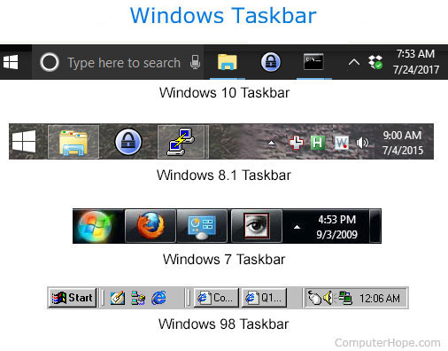

Many windows versions have icons, which are basically pictures or graphically representations of a file, and you can access it by double clicking onto the into.

**Topic C – Memory Allocation, Management,& Devices**

The memory manager implements virtual memory, provides a core set of services such as memory mapped files, copy-on-write memory, large memory support, and underlying support for the cache manager.

<https://docs.microsoft.com/en-us/windows/desktop/memory/memory-management>

Each process on 32-bit Microsoft Windows has its own virtual address space that enables addressing up to 4 gigabytes of memory. Each process on 64-bit Windows has a virtual address space of 8 terabytes. All threads of a process can access its virtual address space. However, threads cannot access memory that belongs to another process, which protects a process from being corrupted by another process. In COM, many, if not most, interface methods are called by code written by one programming organization and implemented by code written by another. Many of the parameters and return values of these functions are of types that can be passed around by value. Sometimes, however, it is necessary to pass data structures for which this is not the case, so it is necessary for both caller and called to have a compatible allocation and deallocation policy. COM defines a universal convention for memory allocation, because it is more reasonable than defining case-by-case rules and so that the COM remote procedure call implementation can correctly manage memory.

<https://docs.microsoft.com/en-us/windows/desktop/memory/about-memory-management>

The virtual address space for a process is the set of virtual memory addresses that it can use. The address space for each process is private and cannot be accessed by other processes unless it is shared.

A virtual address does not represent the actual physical location of an object in memory; instead, the system maintains a *page table*for each process, which is an internal data structure used to translate virtual addresses into their corresponding physical addresses. Each time a thread references an address, the system translates the virtual address to a physical address.

The virtual address space for 32-bit Windows is 4 gigabytes (GB) in size and divided into two partitions: one for use by the process and the other reserved for use by the system. For more information about the virtual address space in 64-bit Windows,

<https://docs.microsoft.com/en-us/windows/desktop/memory/virtual-address-space>

Memory Pools

The memory manager creates the following memory pools that the system uses to allocate memory: nonpaged pool and paged pool. Both memory pools are located in the region of the address space that is reserved for the system and mapped into the virtual address space of each process. The nonpaged pool consists of virtual memory addresses that are guaranteed to reside in physical memory as long as the corresponding kernel objects are allocated. The paged pool consists of virtual memory that can be paged in and out of the system. To improve performance, systems with a single processor have three paged pools, and multiprocessor systems have five paged pools.

<https://docs.microsoft.com/en-us/windows/desktop/memory/memory-pools>

**Topic D – Process / Task Scheduling and Management (System Startup)**

Task Manager is a utility included in Windows that shows you what programs are running on your computer.

Task Manager also gives you some limited control over those running tasks.

### What Is Task Manager Used For?

For an advanced tool that can do an incredible number of things, most of the time the Windows Task Manager is used to do something very basic: see what's running right now.

Open programs are listed, of course, as are programs that are running "in the background" that Windows and your installed programs have started.

Task Manager can be used to [forcefully end any of those running programs](https://www.lifewire.com/how-to-force-quit-a-program-in-windows-2625781), as well as to see how much individual programs are using your computer's [hardware resources](https://www.lifewire.com/what-is-a-system-resource-2626016) and which programs and services are starting when your computer starts.

See [Task Manager: A Full Walkthrough](https://www.lifewire.com/task-manager-walkthrough-4029769) for every detail about Task Manager. You'll be amazed at how much you can learn about the software that's running on your computer with this utility.

### How to Open Task Manager

There is no shortage of ways to open Task Manager, which is probably a good thing considering that your computer may be suffering some kind of problem when you need to open it.

Let's start with the easiest way first: **Ctrl**+**Shift**+**Esc**. Press those three keys together at the same time and Task Manager will launch.

[CTRL+ALT+DEL](https://www.lifewire.com/what-is-ctrl-alt-del-2625830), which opens the Windows Security screen, is another way. Like with most [keyboard](https://www.lifewire.com/what-is-a-keyboard-2618153) shortcuts, press the **Ctrl**, **Alt**, and **Del** keys at the same time to bring up this screen, which includes an option to open Task Manager, among other things. In Windows XP, this shortcut opens Task Manager directly.

Another easy way to open Task Manager is to right-click or tap-and-hold on any empty space on the taskbar, that long bar at the bottom of your Desktop. Choose **Task Manager** (Windows 10, 8, & XP) or **Start Task Manager** (Windows 7 & Vista) from the pop-up menu.

You can also start the Task Manager directly using its run command. [Open a Command Prompt window](https://www.lifewire.com/how-to-open-command-prompt-2618089), or even just Run (**Win**+**R**), and then execute **taskmgr**.

Task Manager is also available on the [Power User Menu](https://www.lifewire.com/what-is-the-power-user-menu-2625968).

### How to Use Task Manager

Task Manager is a well-designed tool in the sense that it's organized and easy to move around in but is hard to fully explain because there are so many hidden options.

In Windows 10 & Windows 8, Task Manager defaults to a "simple" view of the running foreground programs. Tap or click **More details** at the bottom to see everything.

| **Task Manager Explained** | |
| --- | --- |
| **Tab** | **Explanation** |
| **Processes** | The Processes tab contains a list of all the running programs and apps on your computer (listed under Apps), as well as any Background processes and Windows processes that are running.  From this tab, you can close running programs, bring them to the foreground, see how each is using your computer's resources, and more.  Processes is available in Task Manager as described here in Windows 10 and Windows 8 but most of the same functionality is available in the Applications tab in Windows 7, Vista, and XP. The Processes tab in those older versions of Windows most resembles Details, described below. |
| **Performance** | The Performance tab is a summary of what's going on, overall, with your major hardware components, like your [CPU](https://www.lifewire.com/what-is-a-cpu-2618150), [RAM](https://www.lifewire.com/what-is-random-access-memory-ram-2618159), [hard drive](https://www.lifewire.com/what-is-a-hard-disk-drive-2618152), network, and more.  From this tab you can, of course, watch as usage of these resources changes, but this is also a great place to find valuable information about these areas of your computer. For example, this tab makes it easy to see your CPU model and maximum speed, RAM slots in use, disk transfer rate, your [IP address](https://www.lifewire.com/what-is-an-ip-address-2625920), and lots more.  Performance is available in Task Manager in all versions of Windows but is much improved in Windows 10 and Windows 8 compared to earlier versions.  A Networking tab exists in Task Manager in Windows 7, Vista, and XP, and contains some of the reporting available from the networking related sections in Performance in Windows 10 & 8. |
| **App history** | The App history tab shows the CPU usage and network utilization that each Windows app has used between the date listed on the screen through right now.  This tab is great for tracking down any app that might be a CPU or network resource hog.  App history is only available in Task Manager in Windows 10 and Windows 8. |
| **Startup** | The Startup tab shows every program that starts up automatically with Windows, along with several important details about each, probably most valuable a startup impact rating of High, Medium, or Low.  This tab is great for identifying, and then disabling, programs that you don't need to be running automatically. Disabling programs that auto-start with Windows is a very easy way to speed up your computer.  Startup is only available in Task Manager in Windows 10 and 8. |
| **Users** | The Users tab shows every user that's currently signed in to the computer and what processes are running within each.  This tab isn't particularly useful if you're the only user signed in to your computer, but it's incredibly valuable for tracking down processes that might be running under another account.  Users is available in Task Manager in all versions of Windows but only shows processes per-user in Windows 10 and Windows 8. |
| **Details** | The Details tab shows every individual process that's running right now - no program grouping, common names, or other user-friendly displays here.  This tab is very helpful during advanced troubleshooting, when you need to easily find something like an executable's exact location, its PID, or some other piece of information you haven't found elsewhere in Task Manager.  Details is available in Task Manager in Windows 10 and Windows 8 and most resembles the Processes tab in earlier versions of Windows. |
| **Services** | The Services tab shows at least some of the Windows services installed on your computer. Most services will be Running or Stopped.  This tab serves as a quick and convenient way to start and stop major Windows services. Advanced configuration of services is done from the Services module in Microsoft Management Console.  Services is available in Task Manager in Windows 10, 8, 7, and Vista. |

Purpose

The Task Scheduler enables you to automatically perform routine tasks on a chosen computer. The Task Scheduler does this by monitoring whatever criteria you choose to initiate the tasks (referred to as triggers) and then executing the tasks when the criteria is met.

Where applicable

The Task Scheduler can be used to execute tasks such as starting an application, sending an email message, or showing a message box. Tasks can be scheduled to execute:

When a specific system event occurs.

At a specific time.

At a specific time on a daily schedule.

At a specific time on a weekly schedule.

At a specific time on a monthly schedule.

At a specific time on a monthly day-of-week schedule.

When the computer enters an idle state.

When the task is registered.

When the system is booted.

When a user logs on.

When a Terminal Server session changes state.

**Topic E – Software Security, Updates & System Tools**

**Windows Defender** (known as **Windows Defender Antivirus** in [Windows 10 Creators Update](https://en.wikipedia.org/wiki/Windows_10_Creators_Update) and later) is an [anti-malware](https://en.wikipedia.org/wiki/Antivirus_software) component of [Microsoft Windows](https://en.wikipedia.org/wiki/Microsoft_Windows).

It was first released as a downloadable free antispyware program for [Windows XP](https://en.wikipedia.org/wiki/Windows_XP), and was later shipped with [Windows Vista](https://en.wikipedia.org/wiki/Windows_Vista) and [Windows 7](https://en.wikipedia.org/wiki/Windows_7). It has evolved into a full antivirus program, replacing [Microsoft Security Essentials](https://en.wikipedia.org/wiki/Microsoft_Security_Essentials) as part of [Windows 8](https://en.wikipedia.org/wiki/Windows_8) and later versions.

## **Advanced features**

[https://upload.wikimedia.org/wikipedia/en/thumb/3/38/Windows_Defender_EICAR.png/220px-Windows_Defender_EICAR.png](https://en.wikipedia.org/wiki/File:Windows_Defender_EICAR.png)

Windows Defender notification toast in [Windows 8](https://en.wikipedia.org/wiki/Windows_8), reporting taking action to clean the [EICAR test file](https://en.wikipedia.org/wiki/EICAR_test_file).

**Real-time protection**

In the Windows Defender options, the user can configure [real-time protection](https://en.wikipedia.org/wiki/Real-time_protection) options.

**Browser integration**

Integration with [Internet Explorer](https://en.wikipedia.org/wiki/Internet_Explorer) and [Microsoft Edge](https://en.wikipedia.org/wiki/Microsoft_Edge) enables files to be scanned as they are downloaded to detect malicious software inadvertently downloaded. Although it does not integrate with non-Microsoft [web browsers](https://en.wikipedia.org/wiki/Web_browsers), Windows Defender scans for malicious downloaded files as part of its real-time protection.

Windows 10's Anniversary Update introduced Limited Periodic Scanning, which optionally allows Windows Defender to scan a system periodically if another antivirus app is installed.[[4]](https://en.wikipedia.org/wiki/Windows_Defender#cite_note-windowscentral.com-4) It also introduced Block at First Sight, which uses machine learning to predict whether a file is malicious

### Security agents

Security agents which monitor the computer for malicious activities:

* *Auto Start* – Monitors lists of programs that are allowed to automatically run when the user starts the computer
* *System Configuration (settings)* – Monitors security-related settings in Windows
* *Internet Explorer Add-ons* – Monitors programs that automatically run when the user starts Internet Explorer
* *Internet Explorer Configurations (settings)* – Monitors browser security settings
* *Internet Explorer Downloads* – Monitors files and programs that are designed to work with Internet Explorer
* *Services and Drivers* – Monitors services and drivers as they interact with Windows and programs
* *Application Execution* – Monitors when programs start and any operations they perform while running
* *Application Registration* – Monitors tools and files in the operating system where programs can register to run at any time
* *Windows Add-ons* – Monitors add-on programs for Windows

**Windows Update** is a [Microsoft](https://en.wikipedia.org/wiki/Microsoft) service for the [Windows 9x](https://en.wikipedia.org/wiki/Windows_9x) and [Windows NT](https://en.wikipedia.org/wiki/Windows_NT) families of operating system, which automates downloading and installing [Microsoft Windows](https://en.wikipedia.org/wiki/Microsoft_Windows) [software updates](https://en.wikipedia.org/wiki/Software_update) over the [Internet](https://en.wikipedia.org/wiki/Internet). The service delivers software updates for Windows, as well as the various Microsoft [antivirus products](https://en.wikipedia.org/wiki/Antivirus_software), including [Windows Defender](https://en.wikipedia.org/wiki/Windows_Defender) and [Microsoft Security Essentials](https://en.wikipedia.org/wiki/Microsoft_Security_Essentials).

The service provides several kinds of updates. *Security updates* or *critical updates* mitigate vulnerabilities against [security exploits](https://en.wikipedia.org/wiki/Exploit_(computer_security)) against Microsoft Windows. *Cumulative updates* are updates that bundle previously released updates. Cumulative updates were introduced with [Windows 10](https://en.wikipedia.org/wiki/Windows_10) and have been backported to [Windows 7](https://en.wikipedia.org/wiki/Windows_7) and [Windows 8.1](https://en.wikipedia.org/wiki/Windows_8.1).

Microsoft routinely releases updates on the second Tuesday of each month (known as the [Patch Tuesday](https://en.wikipedia.org/wiki/Patch_Tuesday)), but can provide them whenever a new update is urgently required to prevent a newly discovered or prevalent exploit. System administrators can configure Windows Update to install critical updates for Microsoft Windows automatically, so long as the computer has an Internet connection.

Windows Update was introduced as a [web app](https://en.wikipedia.org/wiki/Web_app) with the launch of [Windows 98](https://en.wikipedia.org/wiki/Windows_98) and offered additional [desktop themes](https://en.wikipedia.org/wiki/Theme_(computing)), [games](https://en.wikipedia.org/wiki/Video_game), [device driver](https://en.wikipedia.org/wiki/Device_driver) updates, and optional components such as [NetMeeting](https://en.wikipedia.org/wiki/NetMeeting).[[1]](https://en.wikipedia.org/wiki/Windows_Update#cite_note-1) Windows 95 and [Windows NT 4](https://en.wikipedia.org/wiki/Windows_NT_4)were retroactively given the ability to access the Windows Update website, and download updates designed for those operating systems, starting with the release of versions of [Internet Explorer 4](https://en.wikipedia.org/wiki/Internet_Explorer_4). The initial focus of Windows Update was free add-ons and new technologies for Windows. Security fixes for [Outlook Express](https://en.wikipedia.org/wiki/Outlook_Express), Internet Explorer and other programs appeared later, as did access to beta versions of upcoming Microsoft software, e.g., [Internet Explorer 5](https://en.wikipedia.org/wiki/Internet_Explorer_5). Fixes to Windows 98 to resolve the [Year 2000 problem](https://en.wikipedia.org/wiki/Year_2000_problem) were distributed using Windows Update in December 1998. Microsoft attributed the sales success of Windows 98 in part to Windows Update.

**Automatic Updates** is the successor of the Critical Update Notification Utility. It was released in 2000, along with [Windows ME](https://en.wikipedia.org/wiki/Windows_ME). It supports Windows 2000 SP3 as well.

Unlike its predecessor, Automatic Updates can download and install updates. Instead of the five-minute schedule used by its predecessor, Automatic Updates checks the Windows Update servers once a day. After Windows ME is installed, a [notification balloon](https://en.wikipedia.org/wiki/Balloon_help) prompts the user to configure the Automatic Updates client. The user can choose from three notification schemes: Being notified before downloading the update, being notified before installing the update, or both.

**User Account Control (UAC)** protects users by preventing malware from damaging a machine, and helps organizations deploy a better-managed desktop. When this feature is enabled, apps and tasks always run in the security context of a non-administrator account, unless an administrator specifically authorizes administrator-level access to the system. It can also block the automatic installation of unauthorized apps, and prevent accidental changes to system settings.

Each app that requires the administrator access token must prompt for consent. The one exception is the relationship that exists between parent and child processes. Child processes inherit the user's access token from the parent process. Both the parent and child processes, however, must have the same integrity level. Windows 10 protects processes by marking their integrity levels. Integrity levels are measurements of trust. A "high" integrity application is one that performs tasks that modify system data, such as a disk partitioning application, while a "low" integrity application is one that performs tasks that could potentially compromise the operating system, such as a Web browser. Apps with lower integrity levels cannot modify data in applications with higher integrity levels. When a standard user attempts to run an app that requires an administrator access token, UAC requires that the user provide valid administrator credentials.

**Bitlocker** is a full-drive encryption solution provided natively within Windows 10 Professional and Enterprise, Benoit said. It helps mitigate unauthorized data access by enhancing file and system protections, and renders data inaccessible if the computers are decommissioned or recycled.

**System tools** are computer programs that can be used for implementing different tasks. People download them to the system with specific intentions, such as trying to accomplish needed tasks, seeking to improve its performance and security, getting a better experience while browsing on the Internet or simply fixing specific PC errors. The most of such programs belong to reputable companies, so they are safe and easy-to-use. You can uninstall a system tool from your computer using its uninstall feature.

System tools can be divided into two different categories – legitimate and malicious. Security experts warn people about malicious system tools because they can act on your computer similarly to computer viruses and malware. No matter what is said on such program’s official website, it can start causing unexpected activities right after being installed on a computer. Typically, the questionable versions of system tools cause system slow downs, misleading system scanners, unwanted notifications and pop-up ads, redirects to unknown websites and similar activities. Such system tools can be assigned to “potentially unwanted program” category and should be uninstalled from computer ASAP.

**Topic F – File System & User Accounts**

# WHAT ARE THE DIFFERENT KINDS OF USER ACCOUNTS IN WINDOWS 10?

The system account and the administrator account (Administrators group) have the same file privileges, but they have different functions. The system account is used by the operating system and by services that run under Windows. There are many services and processes within Windows that need the capability to log on internally (for example during a Windows installation). The system account was designed for that purpose; it is an internal account, does not show up in User Manager, cannot be added to any groups, and cannot have user rights assigned to it. On the other hand, the system account does show up on an NTFS volume in File Manager in the Permissions portion of the Security menu. By default, the system account is granted full control to all files on an NTFS volume. Here the system account has the same functional privileges as the administrator account.

Administrator: The administrator controls the entire computer, deciding who gets to play with it and what each user may do on it. On a computer running Windows, the owner usually holds the almighty Administrator account. He or she then sets up accounts for each household member and decides what they can and can’t do with the PC.

Standard: Standard account holders can access most of the computer, but they can’t make any big changes to it. They can’t run or install new programs, for example, but they can run existing programs.

Child: The Child account setting is actually just a Standard account with the Family Safety settings automatically turned on.

Guest: Guests can play with the computer, but the computer doesn’t recognize them by name. Guest accounts function much like Standard accounts but with no privacy: Anybody can sign in with the Guest account, and the desktop will look the way the last guest left it. It’s great for impromptu web browsing but not much else.

**File Systems**

Any computer file is stored on a storage medium with a given capacity. In actual fact, each storage is linear space for reading or both reading and writing digital information. Each byte of information on it has its offset from the storage start known as an address and is referenced by this address. A storage can be presented as a grid with a set of numbered cells (each cell is a single byte). Any file saved to the storage gets its own cells.

Generally, computer storages use the pair of a sector and in-sector offset to reference any byte of information on the storage. A sector is a group of bytes (usually 512 bytes), a minimum addressable unit of the physical storage. For example, byte 1040 on a hard disk will be referenced as a sector #3 and offset in sector 16 bytes ([sector]+[sector]+[16 bytes]). This scheme is applied to optimize storage addressing and to use a smaller number to refer to any portion of information located on the storage.

To omit the second part of the address (in-sector offset), files are usually stored starting from the sector start and occupy whole sectors (e.g.: a 10-byte file occupies the whole sector, a 512-byte file also occupies the whole sector, at the same time, a 514-byte file occupies two entire sectors).

Each file is stored in “unused” sectors and can be read later by its known position and size. However, how do we know which sectors are occupied and which are free? Where are the size, position and name of the file stored? This is exactly what the file system is responsible for.

As a whole, a file system is a structured representation of data and a set of metadata describing this data. It is applied to the storage during the format operation. A file system serves for the purposes of the whole storage and is also a part of an isolated storage segment – a disk partition. Usually, a file system operates blocks, not sectors. File system blocks are groups of sectors that optimize storage addressing. Modern file systems generally use block sizes from 1 to 128 sectors (512-65536 bytes). Files are usually stored at the start of a block and take up entire blocks.

Constant write/delete operations in the file system cause its fragmentation. Thus, files are not stored as whole units, but get divided into fragments. For example, a storage is completely occupied by files with the size of about 4 blocks each (e.g. a collection of photos). A user wants to store a file that will take up 8 blocks and therefore deletes the first and the last files. By doing this, he or she frees the space of 8 blocks, however, the first segment is located near to the storage start while the second one – to the storage end. In this case, the 8-block file is split into two parts (4 blocks for each part) and takes free space "holes". The information about both fragments as parts of a single file is stored in the file system.

In addition to user’s files, the file system also contains its own parameters (such as a block size), file descriptors (including file size, file location, its fragments, etc.), file names and directory hierarchy. It may also store security information, extended attributes and other parameters.

To comply with diverse users' requirements, such as storage performance, stability and reliability, plenty of file systems are developed to be able to serve different purposes more effectively.

File systems of Windows

Microsoft Windows employs two major file systems: NTFS, the primary format most modern versions of this OS use by default, and FAT, which was inherited from old DOS and has exFAT as its later extension. In addition, the ReFS file system was developed by Microsoft as a new generation file system for server computers starting from Windows Server 2012.

FAT:

FAT (File Allocation Table) is one of the simplest file system types, which has been around since the 1980s. It consists of the file system descriptor sector (boot sector or superblock), the file system block allocation table (referred as the File Allocation Table) and plain storage space for storing files and folders. Files in FAT are stored in directories. Each directory is an array of 32-byte records, each defining a file or extended attributes of a file (e.g. a long file name). A file record attributes the first block of a file. Any next block can be found through the block allocation table by using it as a linked list.

The block allocation table contains an array of block descriptors. A zero value indicates that the block is not used and a non-zero one relates to the next block of a file or a special value for the file end.

The numbers in FAT12, FAT16, FAT32 stand for the number of bits used to enumerate a file system block. This means that FAT12 can use up to 4096 different block references, while FAT16 and FAT32 can use up to 65536 and 4294967296 accordingly. The actual maximum count of blocks is even less and depends on the implementation of the file system driver.

FAT12 and FAT16 used to be applied to old floppy disks and do not find extensive employment nowadays. FAT32 is still widely used for memory cards and USB sticks. The system is supported by smartphones, digital cameras and other portable devices.

FAT32 can be used on Windows-compatible external storages or disk partitions with the size under 32 GB (Windows cannot create a FAT32 file system which would be larger than 32 GB, although Linux supports the size up to 2 TB) and doesn't allow to create files the size of which exceeds 4 GB. To address this issue, exFAT was introduced, which doesn't have any realistic limitations concerning the size of files or partitions.

NTFS:

NTFS (New Technology File System) was introduced in 1993 with Windows NT and is currently the most common file system for end user computers based on Windows. Most operating systems of the Windows Server line use this format as well.

The file system is quite reliable thanks to journaling and supports many features, including access control, encryption, etc. Each file in NTFS is stored as a file descriptor in the Master File Table and file content. The Master file table contains entries with all information about files: size, allocation, name, etc. The first 16 entries of the Master File Table are retained for the BitMap, which keeps record of all free and used clusters, the Log used for journaling records and the BadClus containing information about bad clusters. The first and the last sectors of the file system contain file system settings (the boot record or the superblock). This file system uses 48 and 64 bit values to reference files, thus being able to support data storages with extremely high capacity.

ReFS:

ReFS (Resilient File System) is the latest development of Microsoft introduced with Windows 8 and now available for Windows 10. The file system architecture absolutely differs from other Windows file systems and is mainly organized in a form of the B+-tree. ReFS has high tolerance to failures due to new features included into the system. And, namely, Copy-on-Write (CoW): no metadata is modified without being copied; data is not written over the existing data, but into new disk space. With any file modifications, a new copy of metadata is stored into free storage space, and then the system creates a link from older metadata to the newer one. Thus, the system stores significant quantity of older backups in different places providing easy file recovery unless this storage space is overwritten.

For information about data recovery from these file systems please visit Chances for recovery page.

**Topic G – Special Features of your OS**

Cortana is designed to help you get things done. Ready on day one to provide answers and complete basic tasks, Cortana learns over time to become more useful every day. Count on Cortana to stay on top of reminders and work across your devices.

Time-based reminders

Set a reminder with a specific time or day, such as 3PM or every Monday, so Cortana can remind you exactly when you need to know.

Location-based reminders

Set a reminder with a location, such as the grocery store, so Cortana can remind you to pick up milk the next time you are at the store.

Photo reminders

Add a photo to your reminders, like your kid’s favorite game, so you are reminded about it the next time you’re shopping.

Microsoft Edge is a web browser developed by Microsoft. It was first released for Windows 10 and Xbox One in 2015, then for Android and iOS in 2017.

Edge includes integration with [Cortana](https://en.wikipedia.org/wiki/Cortana" \o "Cortana)and has [extensions](https://en.wikipedia.org/wiki/Browser_extension) hosted on the [Microsoft Store](https://en.wikipedia.org/wiki/Microsoft_Store_(digital)). Unlike [Internet Explorer](https://en.wikipedia.org/wiki/Internet_Explorer), Edge does not support the legacy [ActiveX](https://en.wikipedia.org/wiki/ActiveX" \o "ActiveX)and [BHO](https://en.wikipedia.org/wiki/Browser_Helper_Object) technologies.

Features:

Favorites, reading list, browsing history and downloads are viewed at the Hub,[18] a sidebar providing functionality similar to Internet Explorer’s Downloads manager and Favorites Center.[19]

The browser includes an integrated Adobe Flash Player (with an internal whitelist allowing Flash applets on Facebook websites to load automatically, bypassing all other security controls requiring user activation)[20] and a PDF reader. It also supports asm.js.[21]

Edge does not support legacy technologies such as ActiveX and Browser Helper Objects, and instead uses an extension system.[5][22][23] Internet Explorer 11 remains available alongside Edge on Windows 10 for compatibility; it remains nearly identical to the Windows 8.1 version and does not use the Edge engine as was previously announced.[5][13][22]

Edge integrates with Microsoft's online platforms in order to provide voice control, search functionality, and dynamic information related to searches within the address bar. Users can make annotations to web pages that can be stored to and shared with OneDrive,[24] but can't save HTML pages to their own computers. It also integrates with the "Reading List" function and provides a "Reading Mode" that strips unnecessary formatting from pages to improve their legibility.[24]

Preliminary support for browser extensions was added in March 2016, with build 14291; three extensions were initially supported. Microsoft indicated that the delay in allowing extensions and the small number was due to security concerns.[25]

Windows 10's Task View is a system that provides an experience to work more efficiently with multiple apps. with it you can quickly jump between open applications and spread projects onto separate desktops to stay focus on a particular task.

Task View was originally designed to make it easier to see and switch quickly between running applications. However, the feature has been evolving ever since it was first introduced, and now, you can also resume activities you were working in the past, as well as use virtual desktops to organize related tasks.

nside Task View, your running applications will be listed in the middle of the screen, which you can click to switch to a particular app quickly.

[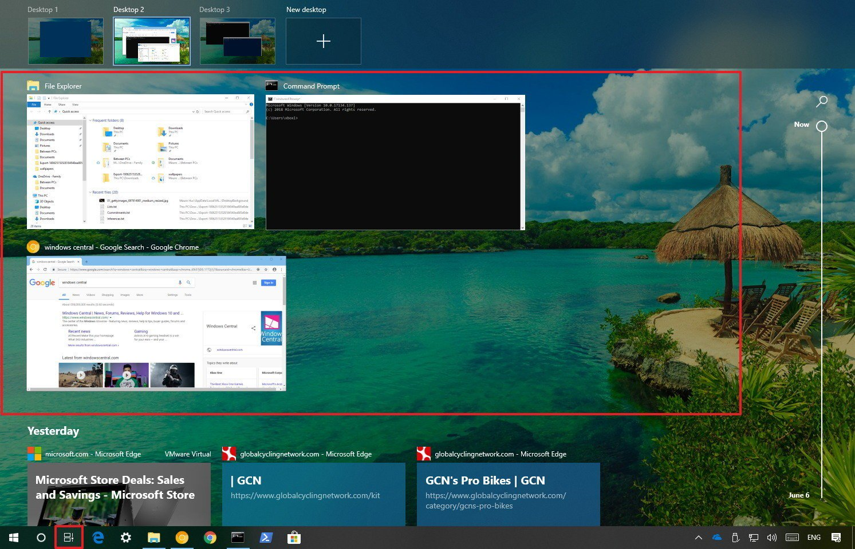](https://www.windowscentral.com/sites/wpcentral.com/files/styles/xlarge/public/field/image/2018/07/task-switcher-windows-10.jpg?itok=xhG5MW2C)

You can also right-click an app to access its context menu to perform some common tasks, including the ability to snap the app to the left or right of the screen, move it to a different virtual desktop or show windows across desktops, and an option to quickly close the application.

[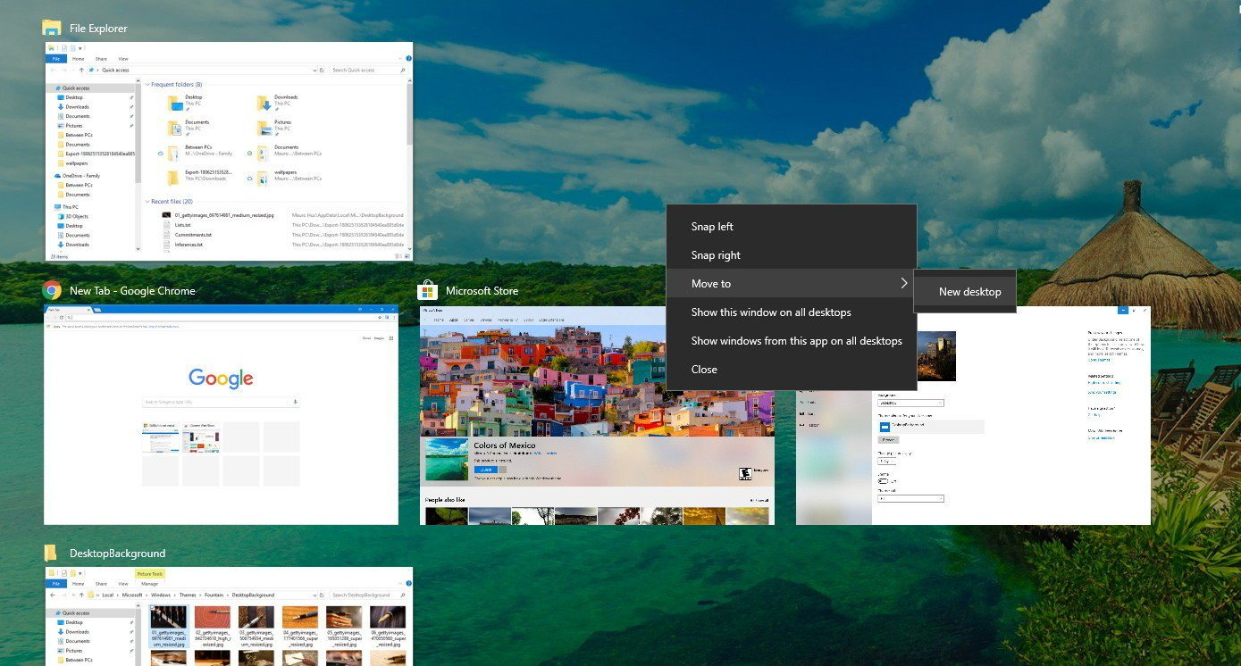](https://www.windowscentral.com/sites/wpcentral.com/files/styles/xlarge/public/field/image/2018/07/running-apps-switcher-windows-10_contextmenu_.jpg?itok=qvdn0RO8)

#### Windows key + Tab vs. Alt + Tab

Since the addition of virtual desktops, there's a slight difference between the **Windows key + Tab**and **Alt + Tab** keyboard shortcuts. While both shortcuts access a list of your running applications, the **Windows key + Tab** only shows the applications running on a particular desktop. It also exposes an interface that includes the controls to manage virtual desktops, and a list of all your Timeline activities.

*[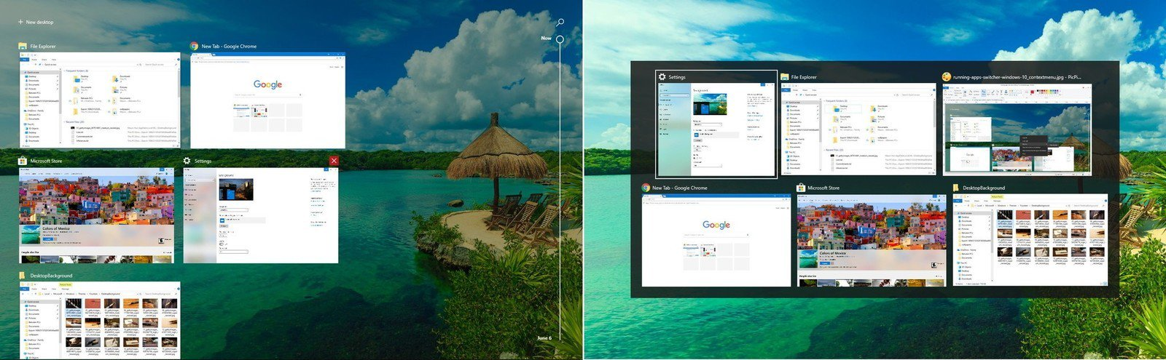](https://www.windowscentral.com/sites/wpcentral.com/files/styles/xlarge/public/field/image/2018/07/windows-tab-vs-alt-tab.jpg?itok=sQRUgc48)Windows key + Tab (left), Alt + Tab (right)*

On the other hand, when using the **Alt + Tab**keyboard shortcut, you're accessing a list of all your running applications no matter in which virtual desktop they're running. In addition, you can keep pressing the shortcut to cycle through apps, and when you land on a particular app, it'll take you to that application on the desktop that's running.

Virtual desktops is an easy-to-use feature in Task View designed to help you organize related activities into groups.

Using this feature, you can create multiple environments that each can run different apps keeping your focus on a particular project. Typically, this feature comes in handy to keep work tasks separate from your personal tasks, or when multitasking between different activities, and you don't have a multi-monitor setup.

#### Accessing virtual desktops

To access the experience, click the **Task view**button in the taskbar or use the **Windows key + Tab** keyboard shortcut.

While in Task View, virtual desktops will appear a the top of the experience.

[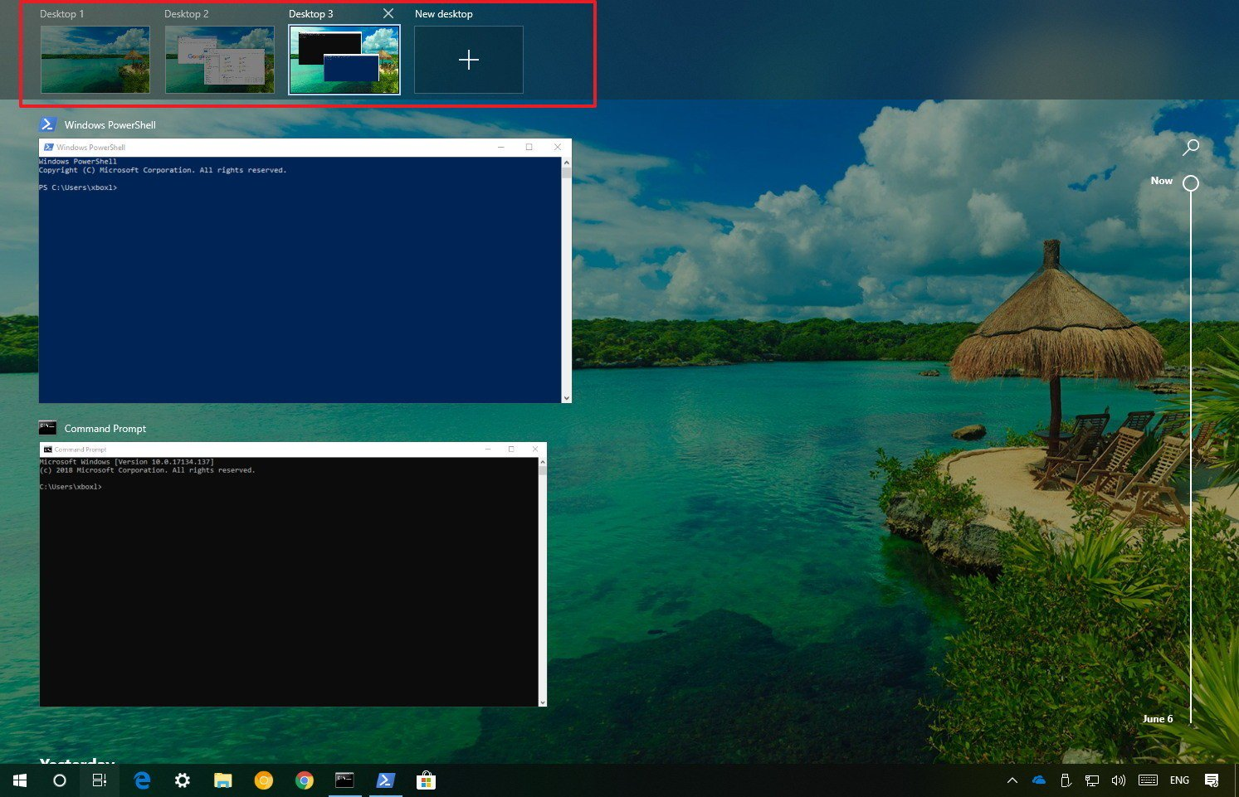](https://www.windowscentral.com/sites/wpcentral.com/files/styles/xlarge/public/field/image/2018/07/virtual-desktops-task-view-preview.jpg?itok=cqyBL-qJ)

If you're using multiple desktops, a preview will appear for each virtual desktop, which you can hover with the mouse to get a quick pick of the apps running in a particular virtual environment.

#### Working with virtual desktops

On Windows 10, you can create as many desktops as you need, the only thing you need to do to start is to click the **New desktop** button.

[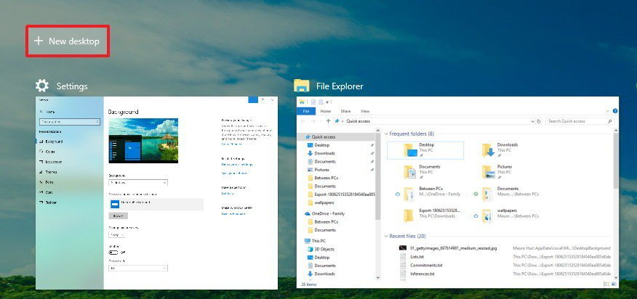](https://www.windowscentral.com/sites/wpcentral.com/files/styles/xlarge/public/field/image/2018/07/task-view-new-destkop-button.jpg?itok=eKdjQ4Bg)

You can also use the **Windows key + Ctrl + D**keyboard shortcut to create a new desktop even faster.

If you want to remove a desktop, simply open **Task View**, and click the **Close (X)** button in the top-right corner of the virtual desktop. (Any running application will automatically move over to your primary desktop.)

Swithching between desktops, just click the thumbnail of the virtual environment you want to use.

[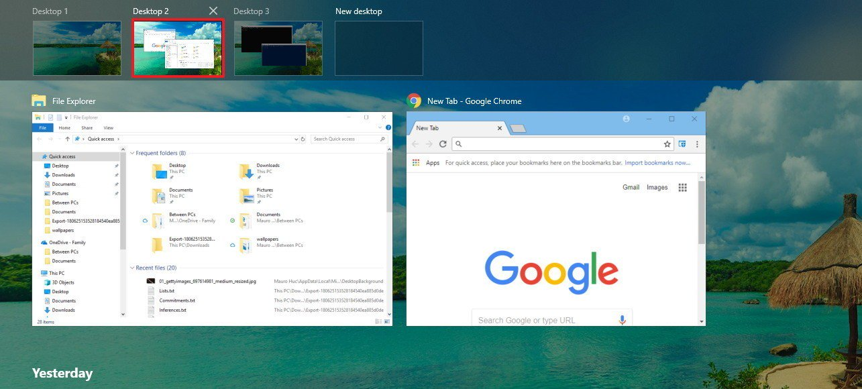](https://www.windowscentral.com/sites/wpcentral.com/files/styles/xlarge/public/field/image/2018/07/switching-desktops-windows-10.jpg?itok=HyIBUcjq)

It's also possible to move quickly between desktops using the **Windows key + Ctrl + Left** or **Windows key + Ctrl + Right** keyboard shortcuts.

If you need to move apps between virtual environments, right-click the app, and select **Move to**, and pick the desktop you want to move the app.

[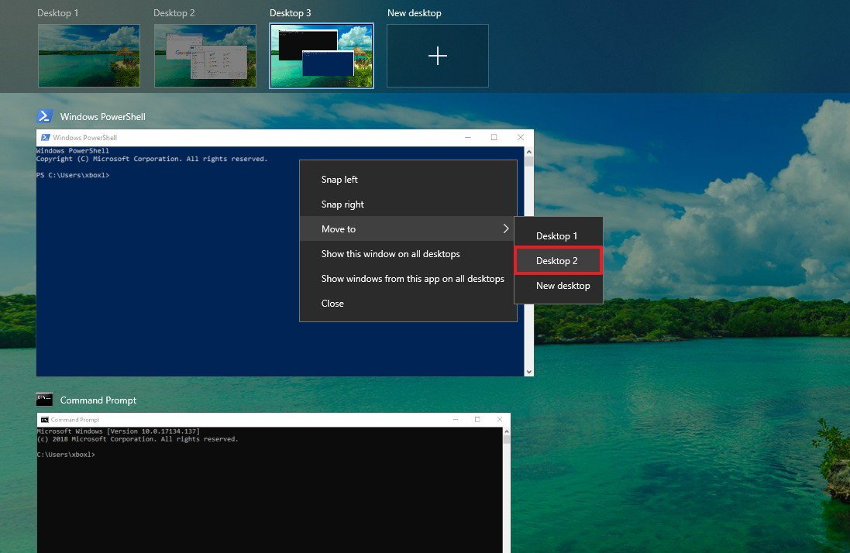](https://www.windowscentral.com/sites/wpcentral.com/files/styles/xlarge/public/field/image/2018/07/move-app-different-virtual-destkop.jpg?itok=_yo0AL1R)

Alternatively, you can drag and drop a running application to the virtual desktop you want. You can even drop the app into the **plus** (+) button, in which case, it'll create a new virtual desktop with the app.

Although virtual desktops is a feature to separate activities into groups, sometimes, you need a particular app to be available on all desktops.

If you need to show an app or a window on all desktops, while in Task View, right-click the app, and select one of two options:

**Topic H – Limitations of your OS**

* The file name resolution of Microsoft Windows is not case sensitive. This can lead to undefined behavior if two files or directories with the same name but different case exists within the same directory and are accessed by a Windows client. Avoid creating files with the same name but different cases over any other protocols (FTP, NFS, HTTP, or SCP) in a directory, which is exported using CIFS.
* Windows clients that are not part of the Active Directory (AD) domain are not able to manage access control lists (ACLs) properly; that is, the clients cannot add domain groups or other domain users. The Windows clients are only able to change the visible settings if the permissions are granted.
* With regard to Windows behavior, there is a placement policy consideration for files that are created with temporary file names. If an application creates a file with a temporary file name, for example New Document.doc, and then changes the file name to a non-default name after the creation, the policy placement rule does not affect the new changed file name. To prevent this scenario a migration policy must be created and this migration policy must be run regularly, using a cron job to move the file to its proper file system pool. While creating temporary files with a temporary name is an exceptional behavior limited to a few applications, such as Microsoft Explorer, most applications, such as Microsoft Office, behave differently when new files are created and stored using the save as option.
* The backward slash (\) is a reserved character and cannot be used in file, directory, and path names.
* Microsoft Windows does not support usage of NLM_NM_LOCK/NM_LOCK for NFS clients. If the client is using NM (not monitored) version of the locks, it means that it is not using Network Status Monitor service. Microsoft Windows supports only a single threaded process model and cannot support a concurrent status monitor process to respond to the state notifications received from the servers.

or over a year we’ve been treated to the fantasy that Windows 10 on ARM was the same as Windows 10 on x86. But it’s a bit more nuanced than that.

Granted, we’ve known some of the differences from the beginning, and we’ve vaguely understood that there would be trade-offs for those moving to this new hardware platform. In particular, the performance of x86 apps, which would need to be emulated.

This week, however, [**Microsoft finally published a more complete list of the limitations of Windows 10 on ARM**](https://docs.microsoft.com/en-us/windows/uwp/porting/apps-on-arm-limitations). And that word—limitations—is interesting. This isn’t how Windows 10 on ARM differs from Windows 10 on x86-based systems. It’s how it’s more limited.

And while we absolutely knew about some of these, the items on this list include.

**64-bit apps will not work.** Yes, Windows 10 on ARM can run Windows desktop applications. But it can only run 32-bit (x86) desktop applications, not 64-bit (x64) applications. (The documentation doesn’t note this, but support for x64 apps is planned for a future release.)

**Certain classes of apps will not run.** Utilities that modify the Windows user interface—like shell extensions, input method editors (IMEs), assistive technologies, and cloud storage apps—will not work in Windows 10 on ARM. They will need to be recompiled for ARM, and my guess is that this will not happen in most cases, especially in the next year.

**It cannot use x86 drivers.** While Windows 10 on ARM can run x86 Windows applications, it cannot utilize x86 drivers. Instead, it will require native ARM64 drivers instead. This means that hardware support will be much more limited than is the case with mainstream Windows 10 versions. In other words, it will likely work much like Windows 10 S does today.

**No Hyper-V.** This was a gray area previously—I’ve heard the phrase “it’s just Windows 10, so it will work” several times—but now it’s real: Hyper-V is not supported in Windows 10 on ARM.

**Older games and graphics apps may not work.** Windows 10 on ARM supports DirectX 9, DirectX 10, DirectX 11, and DirectX 12, but apps/games that target older versions will not work. Apps that require hardware-accelerated OpenGL will also not work.

**Level 2 – Organized Research**

Organize your rough research information to provide more stricture and meaning.

* Re-read your rough research to identify (highlight) important sub-topics and facts
* Rearrange (cut–and-paste) your rough research so that related sub topics and facts are next to each other.
* Your finished organization should look like the template provided below.
* Upload your rough research notes to your repository when you are done.

Suggested organization template:

* Topic A – Productivity, Entertainment & Other Software Applications
  + Sub-Topic 1
    - Fact 1
    - Fact 2
    - …
  + Sub-Topic 2
    - …
  + …
* Topic B – User Interface (Window Management & Input Devices)
  + …

Topic A- Productivity, Entertainment & Other Software Applications:

**Topic A – Productivity, Entertainment & Other Software Applications**

Software:

* Calculator
  + Standard, Scientific and converter
* Alarms and Clock
  + Alarm, Timer, Stopwatch and World Clock
* Calendar
  + Allows for scheduling
* Music
  + Windows media player, groove music, or Music preview

Some Apps only on windows:

* Adobe Atmosphere
* AutoCAD Architecture
* Autodesk Revit
* Bandicam
* Daemon Tools
* Disc2Phone
* Microsoft Office
* Norton AntiBot
* Roxio Creator
* SHAZAM
* Solidworks
* SpyHunter
* SliderDock
* SYSTAT
* Vegas Pro
* WinFax
* Win

**Topic B – User Interface (Window Management & Input Devices) Window interfaces:**

Taskbar:

* Located at the bottom of the screen
* Allows you to locate and launch programs
* On all versions of windows

Speech Recognition:

* Voice commands
* Interprets spoken words to do a task

Start Menu:

* Primary location to locate and access files
* Accessed by clicking the windows logo in the bottom left of the screen

**Topic C – Memory Allocation, Management,& Devices:**

Virtual Address:

* A set of virtual memory addresses
* Virtual address
  + Does not represent the physical location of an object in memory
  + The system maintains a page table for each process
    - Which is an internal data structure
      * Used to translate virtual addresses into their corresponding physical addresses
  + Each time a thread references an address
    - The system translates the virtual address to a physical address
  + The virtual address space for 32 bit windows is 4Gb
    - Divided into two partitions
      * One for use by the process
      * One for use by the system

Memory Pools:

* The memory manager
  + Creates memory pools that the system uses to allocate memory
    - Nonpaged pool
      * Consists of virtual memory addresses
        + Which reside in physical memory as long as the corresponding kernel objects are allocated
    - Paged pool
      * Consists of virtual memory
        + Which can be paged in and out of the system
  + Both are in the region of address space that is reserved for the system and mapped into the virtual address space of each process

**Topic D – Process / Task Scheduling and Management (System Startup):**

Task Manager:

* A utility included in windows
  + Shows you what programs are running on your computer
  + Also gives limited control over those running tasks
  + To open press CTRL+ALT+DEL then select Task Manager
  + Shows Performance, Running processes, App history, Startup applications, Users, and etc

Task Scheduler:

* Automatically perform routine tasks on a chosen computer
  + Monitors whatever criteria you choose to initiate the tasks and then executes the task when the criteria is met
* Can be used to execute tasks such as
  + Starting an application
  + Sending an email
  + Showing a message box
* Tasks can be scheduled at
  + At specific time
  + Daily schedule
  + Weekly Schedule
  + Monthly Schedule
  + On Boot
  + When a User Logs on

**Topic E – Software Security, Updates & System Tools**

Windows Defender:

* Anti-Malware component of Microsoft windows
  + Comes with windows versions of windows after windows Vista
* Browser integration
  + Integration with internet explorer and Microsoft edge
    - Allows files to scanned as they are downloaded to detect malicious software
    - It does not integrate with non-Microsoft browsers but still scans after the file is downloaded
* Limited Periodic Scanning
  + Allows Windows defender to scan a system periodically if another antivirus is installed
* Block at First Sight
  + Uses machine learning to predict whether a file is malicious

Security Agents:

• Auto Start – Monitors lists of programs that are allowed to automatically run when the user starts the computer

• System Configuration (settings) – Monitors security-related settings in Windows

• Internet Explorer Add-ons – Monitors programs that automatically run when the user starts Internet Explorer

• Internet Explorer Configurations (settings) – Monitors browser security settings

• Internet Explorer Downloads – Monitors files and programs that are designed to work with Internet Explorer

• Services and Drivers – Monitors services and drivers as they interact with Windows and programs

• Application Execution – Monitors when programs start and any operations they perform while running

• Application Registration – Monitors tools and files in the operating system where programs can register to run at any time

• Windows Add-ons – Monitors add-on programs for Windows

Windows Update:

* Is a Microsoft service
* Automates downloading and installing Microsoft windows software updates
* Also delivers updates for Antivirus
  + Windows defender
  + Microsoft security essentials
* Updates to mitigate vulnerabilities against security exploits against Windows
* Releases updates on the second Tuesday of each month
  + But can provide update if urgently required

User account Control:

* Protects users by preventing malware from damaging a machine
  + Apps and tasks always run in non-administrator mode
  + Only if the administrator authorizes administrator level access to the system then can it do anything
    - When a software wants administrator access
      * A prompt is shown, and the user decides whether they want to give the software access.

Bit locker:

* Is a full drive encryption solution
  + Helps diminish unauthorized data access by strengthen file and system protections and can render data inaccessible in some cases

System Tools:

* Computer programs that can be used for Usually for specific tasks
* Divided into two different categories
  + Legitimate
  + Malicious
    - Can have effects similar to viruses and malware
    - When downloading these it will say
      * Potentially unwanted program or this program may harm your computer

**Topic F – File System & User Accounts:**

User accounts:

* Administrator
  + Controls the entire computer
* Standard
  + Can control most of the computer
  + Can not make big changes
    - Installing and uninstalling programs
* Child
  + Standard account with Family Safety Settings turned on
* Guests
  + Basically a standard account but you can not do anything except simple tasks like browsing and etc

File Systems:

* Computer files are stored on a storage medium with a given capacity
* Each byte of information on it has its offset from the storage start known as an address and is referenced by this address
* A storage
  + Can be represented by a grid with set of number cells
  + Any file saved to the storage gets its own cells
* Uses pair of sector and in sector to reference any byte of information
  + A sector is a group of bytes (512 bytes)
    - Minimum addressable unit
  + Used to make storage addressing more efficient
* Constant write/delete operations cause fragmentation
  + Where the files which were stored in whole units get divided into fragment
* Microsoft uses two major file systems
  + NTFS
    - The primary format
    - Includes
      * Access control
      * Encryption
    - Each file is stored as a file descriptor
      * In the master file table and file content
      * The master file table
        + Contains entries with all information about files like size, name, allocation and etc.
  + FAT
    - Came from the old DOS and has exFAT as its later extension
    - Consists of the file system descriptor sector, the file system block allocation table and plain storage space.
      * Files in fat are stored in directories
      * Each directory is an array of 32-byte records
        + Each defining a file
        + A file record defines the first block of any file
        + The next block can be found through the block allocation table

It contains an array of block descriptors

A zero indicates that the block is not used

Any other number other than zero relates to the next block of a file or a special value for the file end

* Microsoft also made ReFS file system
  + For server computers starting from windows server 2012
* ReFS
  + Organized in a form of the B+- Tree
  + High tolerance to failures due to new features
  + Copy-on-write
    - No metadata is modified without being copied
    - Data is not written over the existing data but into new disk space
    - Meaning the system stores a large quantity of older backups providing easy file recovery

**Topic G – Special Features of your OS:**

Cortana:

* Designed to help you get things done
* Provides answers and helps complete basic tasks
* Gives reminders
  + Time based reminders
  + Location based reminders
  + Photo reminders

Microsoft edge:

* Released for windows 10
* Integration with Cortana
* Features
  + Favorites
  + Reading list
  + Browsing history
  + Downloads
* Integrated Adobe Flash Player
* Integrates with Microsoft online platforms
  + Voice control
  + Search functionality
  + Dynamic information
  + Reading mode

Task View:

* Allows you to jump quickly between open applications and spread apps onto separate desktops
* Press Windows key+TAB to open virtual desktops
* Press ALT+TAB to switch between programs

**Topic H – Limitations of your OS:**

* Limitations on the size of the files name
* Files with the same name but in different cases can create undefined behavior
  + Example:
    - “hello.txt” and “HELLO.txt”
* The Backward slash is a reserved character and can not be used in file, directory or path names
* Windows 10 ARM
  + 64 bit apps will not work
  + Can not use x86 drivers
  + Older games and graphics may not work

**Level 3 – Concept Map**

Create a “concept map” as a final report of your organized research.

Use the PowerPoint template provided as a starting point.

You can use PowerPoint or another concept mapping tool of your choice.

Select the best and most interesting information from your organized research.

Summarize and edit your information to fit on the concept map.

Share your finished concept map with Mr. Nestor at p0079141@pdsb.net

A concept map can be created using the “Smart Ideas” application or PowerPoint or other applications. A concept map template can be downloaded from the “Topic A” folder on the class GitHub repository

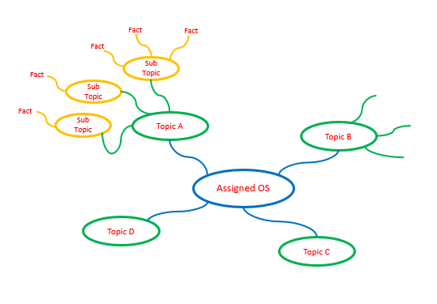

<https://www.mindomo.com/mindmap/ead5daf20c30467da8945574d10ff266>